Kratos Axis Ultra XPS System

Overview: X-ray Photoelectron Spectroscopy (XPS) is an analytical technique that directs a monochromatic beam of x-rays onto a sample and detects the characteristic electrons that are ejected. The energies and number of these electrons can be used to determine not only the elements present on the sample surface, but their abundance and chemical bonding state as well. Elements from Li to U can be detected. The technique is highly surface sensitive – the typical detection depth is ~5 nm – and can detect light elements such as Si (Z =14) and below at about 1% of the total surface composition and heavier elements down to ~0.1 % with an accuracy of 20 – 50 percent of the given value.
The Axis Ultra XPS system can do line – and area – scans, depth profiles, angle-resolved XPS measurements (AR-XPS), and has a 21 eV He-ion UV light source for Ultraviolet Photoelectron Spectroscopy (UPS).
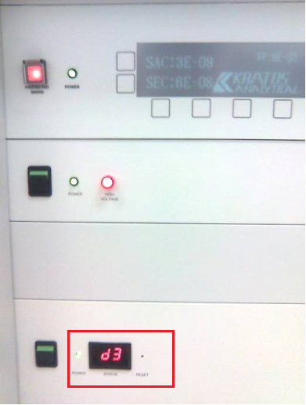
Getting Started: The Vision Manager software should already be running when you log in. If it is not, open it from the shortcut on the desktop (see image at far left) and wait for it to finish initializing communication with the system.
When the software is running, check the communication status indicator on the front of the system under the vacuum control unit (image at left). It should read “d.3” with the dot flashing. If it reads anything else, in particular “E5”, then you will need to close the Vision Manager software and then re-open it.
If a Manual control window is not already open, click on Window/Manual Control in the Manager window to open one. When you scroll to the bottom of the Manual window, the Sample Analysis Chamber (SAC) and Sample Transfer Chamber (STC) pressures should be displayed in bold text as shown above.
If the “Axis Ultra Logbook” Excel file is not already open, click its shortcut on the desktop. Enter the information for your run and save the file. Please note and report any large deviations from normal chamber pressures – THEN WAIT to hear back from the trainers – before continuing with your experiment.
Loading a sample: Check to make sure that there is no sample in the SAC. If a sample has been left there, you will first need to transfer it to the STC before venting the STC to exchange sample holders, (See “Transferring Samples” section below). Before venting the STC to load your sample, YOU MUST CHECK THE MANUAL ISOLATION VALVE ON THE STC CHAMBER. The valve should be closed to finger-tight torque. Failure to check this valve could cause the entire system to be accidentally brought to atmosphere and WILL result in loss of access to the system.
In the Manual Control window, in the vacuum section at the bottom, Make sure the “Automatic Sequences” button is selected (i.e., pushed in) and click Vent STC. You should see a progress indicator appear in the small vacuum diagram. Loosen the 3 bolts that secure the STC door. After 3 – 5 minutes, when the system is fully vented to atmospheric pressure, there will be a visible gap between the door and the flange. Remove the old sample holder – if present – and load your sample using the black metal wand. The sample transfer arm should hook onto the top slot of the sample holder. Samples should be no larger than 25 mm x 25 mm x ~5 mm thick. Close the STC door, tighten the bolts to finger-tight and click Pump STC. You may need to press the STC door closed for a few seconds until the vacuum is low enough to seal the door. Then you should again tighten the bolts to finger-tightness. It should take 5 – 15 minutes for the STC to reach 5E-7 mbar, which is the maximum transfer pressure.

Transferring Samples: If the SAC and STC pressures are in a normal range (typically < 1E-8 for the SAC and < 5E-7 for the STC) then you can begin to load/unload your sample(s). Do the following:
- Click Open STC-SAC Valve and wait/watch for the valve to fully open.
- While looking through the small bottom viewport, turn the knob on the transfer arm clockwise to drive the sample holder into the analysis chamber
- When you can see the sample holder through the viewport, carefully bring it to just in front of the fork in the analysis chamber.
- Adjust the X, Y, and Z micrometers on the sample stage to align the sample stage opening with the bottom slot in the sample holder (typical values are X: 18 - 22, Y: 9.5 – 11, Z: 10.8 – 11.1).
- Gently turn the sample advance knob to slide the sample holder all the way to the left onto the sample stage arm. If there is friction, slowly back up, adjust the micrometers, and try again.
- Once the sample holder is in place, you need to unhook it from the transfer arm by turning the Y micrometer clockwise (i.e., to smaller Y values) until it stops.
- Carefully turn the sample advance knob counterclockwise to retract the transfer arm being careful that it does not touch the sample holder.
- When the hook on the sample transfer arm is clear of the sample holder, retract it all the way back to its stop position (the indicator must become green), then click Close STC-SAC Valve.

System Setup and Alignment:
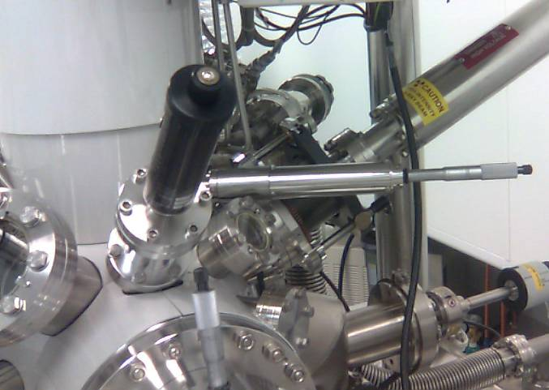The spot size for the Kratos XPS is defined by the micrometer settings of the aperture and iris on the analyzer column. All of the X-ray sources and the UV source illuminate a large area on the sample. The aperture (thin horizontal silvery cylinder outlined in red below) and iris (larger black cylinder outlined below) settings define the area that is focused onto the detector. Generally the slot setting gives the most counts and should be used for large-area, homogeneous samples. Depth profiles are typically done using the 110-um spot and UPS with the 110 or 55-micron spot.
Spot Size [mm] | Iris Setting | Aperture Setting
Slot (~300 x700) | 0.5 | 48.6
110 | 0.5 | 29.0
55 | 0.375 | 22.6
27 | 0.325 | 16.6
15 | 0.25 | 10.6
For the iris, settings in-between the values given above will still allow transmission, but may blur the edges of the defined area. For the aperture, in-between settings will completely block photoelectron transmission.
Once the sample is loaded, begin powering on the Analyzer, X-ray gun, and Neutralizer
- At the top of the Manual Window, click (i.e., “push in”) the buttons for Analyzer, Acquisition, X-ray Gun, Neutralizer, and Vacuum as shown below. (You can enable the other options but they are not necessary for standard XPS).

- The analyzer parameters are (Typical parameters for XPS survey scan in bold):
  - Mode (Spectrum, Imaging)
  - Lens (Hybrid, Electrostatic, UPS, Field of View2: small spot)
  - Pass Energy (160, 80, 40, 20, 10, 5)
- For the X-ray Gun section, click the Status button to show the values being output by the system.
  - Parameters are:
    - Source (Mono Al, Al, Mg)
    - Emission current (mA): (1 – 20, typically 15)
    - Anode HT (kV): (1 – 15, typically 15)
  - Remember to type ENTER after typing in each setting.
  - Click the Standby Button. The indicator will flash orange then light up green when the system is warmed up. Also the “Xray” text at the bottom of the Manual window should become bold and read “Xray(STB)”. When the standby indicator is green, you may click the On button to power up the x-ray source chosen. You should hear the booster pump engage and the “X-Rays ON” lamp at the back of the system should light. In the Status section of the X-ray Gun window, note and record the water flow rate for the source you have selected (typically ~7.3 liters/s for the mono-Al source) in the Excel spreadsheet system log.
- For the Neutralizer, typically you only need to click On in the Neutralizer section.

Now you need to adjust the sample X and Y positions to analyze the correct area and optimize the sample (Z) height. Use the X and Y micrometers from the “Transferring Samples” section to bring the area of interest on the sample to the center of the live video monitor.
The Acquisition Window has the following parameters. Select those shown in bold:
- Technique (ISS, UPS, XPS)
- Type (Spectrum, Map, Linescan, Snapshot)
- B.E., or K.E.
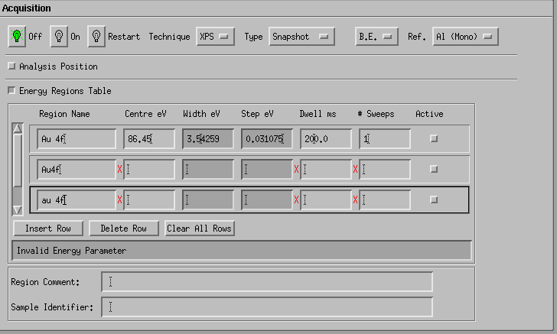Click the Energy Regions Table button and set up the following:
- Region Name must be the correctly-typed XPS label for an elemental XPS doublet. So “Au 4f” will work, but “Au4f”, “au 4f”, etc. will not as shown at left.
- Typically “C 1s” or “O 1s” will be the peaks to choose for adjusting the Z-height. For certain samples (e.g. clean gold films), another peak may be more prominent. You may need to center the C 1s peak at 284 eV instead of its default 288 eV.
- In the Analyzer Section, set the Pass Energy to 80eV. In the Acquisition Section, confirm that the scan Width is ~7 eV.
- Set the Dwell time to ~200 ms.
- 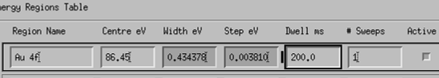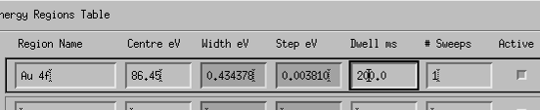IMPORTANT!! When you enter a new value in one of the fields, you will see a black bar on the left side of the edited value (see “Dwell” setting at left). This bar means that the change HAS NOT been accepted by the system. If you run either a manual scan or an experiment without clearing the black bar, the system will use the previously displayed value for this parameter. To set the parameter to the value that you typed, click in the field of the parameter(s) with bars and press ENTER. The bar will disappear and the change will be saved.
- In the Energy Regions Table in the Acquisition section, click the box at the end of the row (i.e., make sure that it is pushed in) to make the scan Active.
- In the top menu of the manager window, click “Window” and select “Real-Time Display”
- Back in the Manual Control window, click “On” in the Acquisition section to start the snapshot scan.
After a ~15-second wait, in the Real-Time Display you will see the system parameters change and then a snapshot acquisition will begin and run indefinitely. You should see a constantly updating peak roughly centered in the display window.
You can look at either the total Area under the curve or the scan-by-scan intensity at the center position, shown by the ratemeter line in the bottom left view to get an idea of the intensity. Adjust the Z-micrometer to maximize either signal which should bring your sample to the optimum Z-height for analysis. You can also optimize the signal by fine tuning X, Y, and the tilt axis θ. When the signal is maximized, stop the snapshot by un-clicking the “Active” button in the Energy Regions Table.

Setting up and Running Experiments:
Experiments are defined and executed from the manager window. There are some specific steps to follow in order to get the result that you expect.
In general the steps to set up an experiment are – in order:
- Define a dataset where the scan data will be stored
- Create and edit the separate acquisition steps for the experiment
- Submit the experiment to the software for execution

Defining the dataset
- In the manager window, begin by Selecting File/New Run to create an experiment, or – if editing a previously saved experiment – File/Load Run.
- Right click in the Acquisition Status window (see above) and select an empty flow chart.
- Select the "Dataset" window above the parameter entry window by left clicking the bubble next to "dataset" (see below).
- Browse for an existing dataset or create a new one by finding the folder you wish the dataset saved in and typing a sample name – no spaces allowed – under the selection dialogue box and clicking "Ok" (see below).
- Once all parameters are set for your dataset (including changing the name of the dataset by changing the text in the “Name” field at the top of the window), paste the dataset into the acquisition status window by clicking in that window with the middle button (i.e., the scroll wheel).

Setting acquisition parameters
- Open the acquisition parameter list by clicking the acquisition button (see below).
- Change the name that will be displayed in the flow chart by changing the text in the “Name” field at the top of the window (see above). Note, once an acquisition step is added to the Run, its name cannot be changed even though its parameters can be edited.
- For a survey scan set the following parameters:

Analyser section:
• Analyser Mode: Spectrum
• Lens Mode: Hybrid - Survey
• Resolution: Pass energy 160 eV
• Slot (or whichever setting is needed for desired spot size)
Excitation section:
• Source: Al (mono)
• Emission: 15 mA
• Anode HT: 15 kV

Scan Control:
• Type: Spectrum
• Energy: Binding Energy
• Reference: Al (mono)

in the Scan Control/Energy Regions section:
• region name: Survey - N.B. (Typing in the word ‘Survey’ and pressing
return in the region name box will automatically enter the default vales.)
• Start: 1200 (centre 597.5)
• End: -5 (width 1205)
• Step: 1
• Sweep: 120.5 (dwell 100 ms)
• # sweeps: 1
• Ensure Active button is selected

- After all these parameters are entered (or whatever parameters are desired for the data that needs to be collected), center click in the acquisition status window to copy the acquisition settings into the flowchart under the dataset.
- To edit the parameters for an acquisition step, click on the tile (i.e., the rectangle icon) next to its name in the acquisition status window. When the tile is black, the step can be edited. To de-select the step, click anywhere in the gray open area of the acquisition status window. When the tile is gray – even though the values in the parameter entry window may be identical to the acquisition step just added – you are simply editing a virtual acquisition file and not making changes to an actual step unless you center-click and add it to the Run.
- After this is completed (as many acquisitions as are desired can be input) one must hit the submit button to begin analysis of the sample.

Higher resolution scans:
- For higher resolution scans of a narrower eV range change the following settings:

Analyser section:
• Analyser Mode: Spectrum
• Lens Mode: Hybrid - Survey
• Resolution: Pass energy 10, 20, or 40 eV
• Slot (or whichever setting is necessary for desired spot size)

Excitation section:
• Source: Al (mono)
• Emission: 15 mA
• Anode HT: 15 kV

- To scan around a certain peak, type the desired element and shell (e.g., "Al 2p," "O 1s," etc.) into the region name box under the scan control menu and hit enter. This will automatically fill in the desired values for the scan range.
Remember to center click to copy the acquisition recipe into the acquisition status window (top left corner) before running the experiment.
Running the Experiment
To run the experiment, do the following:
- Click “Resume”, which sets the system back to Automatic control.
- Next click “Submit”, which enters the Run information into the program’s memory and begins acquisition.
- Finally, from the menu select Window/Real time display - if one is not already open - to view the data.

The current dataset will be shown when the “Acquiring” button is clicked in the Data Region Window at bottom left. The acquisition that is running will be displayed as a pink tile. The actual scan data will be displayed in the Real-time window.

