Thermo K-Alpha XPS Instructions
X-ray Photoelectron Spectroscopy (XPS) is an analytical technique that directs a monochromatic beam of x-rays onto a sample and detects the characteristic electrons that are ejected. The energies and number of these electrons can be used to determine not only the elements present on the sample surface, but their abundance and chemical bonding state as well. Elements from Li to U can be detected. The technique is highly surface sensitive – the typical detection depth is ~5 nm – and can detect light elements such as Si (Z =14) and below at about 1% of the total surface composition and heavier elements down to ~0.1 % with an accuracy of 20 – 50 percent of the given value. This system uses an Aluminum K-Alpha 1.486 KeV source.
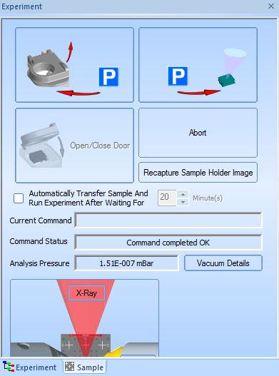

Initial Checks
- The software should be running when you log in. If it is not, double-click the shortcut labeled “Avantage” and wait for the software to load fully.

- Note the reading in the “Analysis Pressure” box on the Sample Tab. The pressure should be in the 10⁻⁹ to low to mid 10⁻⁸ mBar range. If it is a little high, wait ~10 minutes to see if it decreases. If it stays very high (mid to high 10^{-7 or} 10⁻⁶ mBar) and does not drop, please contact a MCF staff member. Fill out the excel log sheet on the desktop called “PRESSURE LOG”.

Loading the XPS
- The XPS can accommodate thin films, bulk samples up to ~ 1cm thick, and powder samples. The sample stage is 60 mm by 60 mm and can hold as many samples as will fit into this area. Films can be inorganic or organic/biological as long as they are properly cured and/or dried. If you have questions about the compatibility of your sample(s) please talk to the trainers.
- The system should be pumped down when you arrive. To load your samples, you must first vent the load lock to get the sample holder. Click the top left sample transfer button to change the system from the “Park” status, (i.e., sample holder in load-lock and pumped down) to Vented status and open the door.
- Make sure to follow cleanliness rules for UHV systems. These include: no bare skin, hair, or moisture in contact with samples or sample holder; use clean tweezers; wipe down surfaces when in doubt; et cetera. The door will spring open after ~5 minutes. Take out the sample holder and put it on a Texwipe or in the Teflon holder. If you need more than a minute to load your samples, click the bottom left button to close the load lock door.
- The sample is held by the spring clips which should be on the stage. One or two clips should be enough to hold a sample
- securely. Don’t push the clips all the way flat as they will break. After securing the sample, pick up the stage and check that the sample won’t fall off when the stage is tilted. Wipe down the stage surface and the clips you are using with IPA and dry completely. Alternatively, double-sided carbon or copper tape can be used. No scotch tape is allowed.
- Make sure that the top of the tallest sample is below the metal bar when the sample is well seated in the Teflon holder. If the sample is too tall, you can lower the stage top by loosening the screws on both the sides and moving them to one of the other slots. Note: Use the stage on the tallest setting that fits under the metal bar.
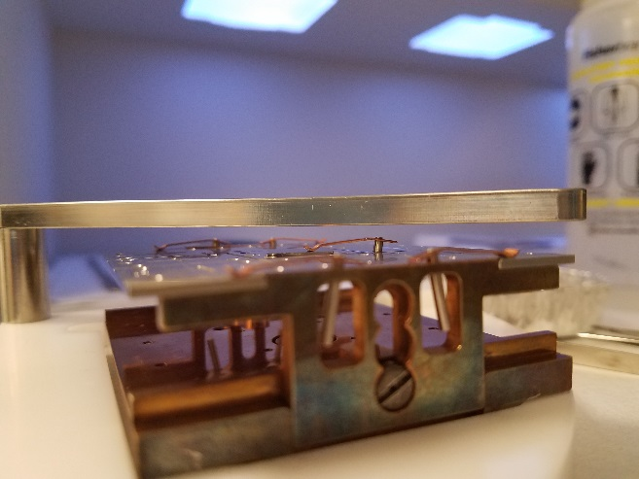

- If you closed load lock door, click the lower left button to open the door. Clean the load lock with textwipe and IPA (IsoPropyl Alcohol, yellow bottle). Put the sample holder on the transfer arm. The holder will only fit correctly one way, which is if the letters “A…B…C” are closest to the analysis chamber. Check that the O-ring is firmly inside the groove by running your fingers all the way around the O-ring. Click the top left button to close the door and pump down the load lock (i.e., put the system In the Park state). When the system reaches park, you need to wait 15 minutes for dry, non-porous substrates; or at least 30 minutes for samples which are porous, powder, or contain some unevaporated solvent. Note the analysis chamber pressure when the sample transfer occurs, should be below the transfer pressure of 4.5 x10⁻⁷ mbar. If the Pressure goes higher, let the transfer step complete then put the sample back to Park (that is in the load lock under vacuum) and wait for another 10-15 minutes before transferring again. You may have to repeat the above two steps if needed.
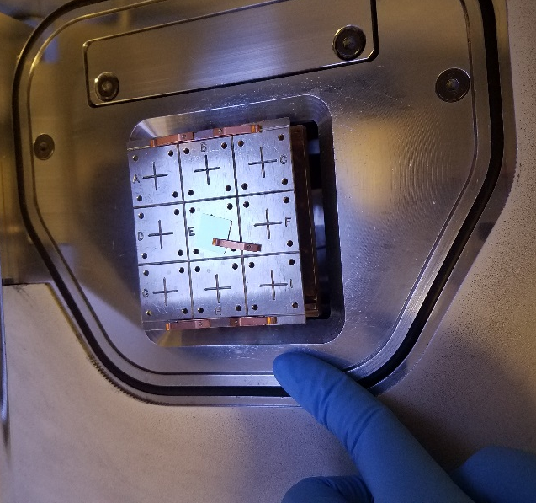
- Note the pressure when your sample arrives in the analysis chamber. It should be stable (increasing means the sample is outgassing) before you run the experiment.

Setting up an Experiment
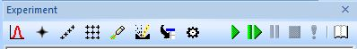
- Switch to the Experiment Tab. Click Apply to save changes after adding anything to the recipe from the tool box.

- Change the experiment folder to your folder in XPS Users
- Select the experiment, then add an x-ray source through Source: Gun. You can choose the spot size you want from 30 to 400 microns and decide whether to use the flood gun (reduces charge shifting. Usually used).
- Select the x-ray gun, then add a point through Point: point. You should put a check in the “Enable Auto-Height” box on the Position tab, then click apply. On the Auto-Height tab, you should click the “Relative Range” radio button and use +-1000um. You can also rename the point.
- Select the point, then add scans through Spectrum: Multi Spectrum. From the periodic table dialog that pops up, you can choose the elements for which you want to perform high-resolution, element-specific scans. You should also check the box for Survey scan to run a general, wide-range scan to look at all of the elements present on the surface. Click OK and the scans will be added as a sub level of the Point. For the survey scan, change number of scans to 2, dwell time to 50 ms, Pass energy to 200, Step size to 1eV. For elemental scans, set the scan time to 50ms, Pass energy 50eV, Step size 0.1eV, and the default Number of scans, 5 to 10
- Finally, turn off all the guns through Source: Gun Shutdown. In the properties box, make sure that all of the guns (X-Ray, Flood, Ion and Manual X-Ray gun) are checked.
- Add as many points as needed, as long as they are within an x-ray source and are followed by gun shutdown. You can also copy paste the point after all the parameters have been saved. You can also add a line or grid instead of multiple points( you will need to specify x and y spacing)
- After the experiment is set up, you can save the experiment in your file for future use through File/Save Experiment As
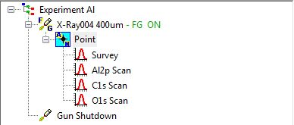

Focus on the sample in the Analysis chamber

When your sample has been transferred into the analysis chamber, you should see 2 images. The top image is a photo taken from the load lock. The red cross is the position of the analysis camera and the green cross(s) the position(s) of the points you have specified. The bottom picture is a live feed from the camera in the analysis chamber. Please turn on the light. You may use the top down or side lamp or both. If you don’t see the image of the sample stage, click the black microscope icon in the top center of the screen - or navigate to Window/Optical View using the top menu – to open the video window.
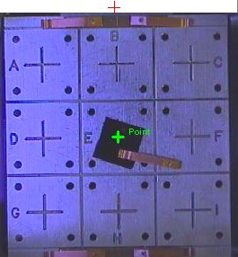
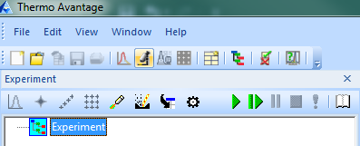

You can drag the green crosses to where you want to scan your sample. Then you can move the camera to your point(s) by any of these 3 methods
    - Double clicking on or near the point in the upper sample stage image
    - Clicking on the point icon in the Experiment tree then clicking Move on the Position tab
    - Using the arrows on the bottom magnified view to navigate around the sample stage
When you have fine-tuned the X, Y, and Z (focus) positions using the crosshairs in the magnified view; select the point that you want to set, click Read, then Apply to set the final positions for your points. The scale bar on the bottom view can be always used as for reference.

Running an Experiment
When you have finished setting up your experiment, check
- The experiment was set up correctly: check over each of the levels to make sure that you have set the parameters for the source(s), point(s), and scan(s) appropriately.
- The analysis chamber pressure. It should be stable at or below 2x10⁻⁷ mbar or decreasing
- The sample is properly focused.

If everything is okay, click the green RUN icon on the top row of icons.

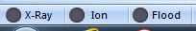
The Current data view window will pop up to fill the screen. The program will execute in the sequence that you have set up. As the X-Ray, Flood, and Ion guns ramp up and turn on, their status indicators at the bottom of the recipe window change from flashing blue to green. Grey means they are off.

When data collection begins, the incoming raw data is shown in the Current data window. To perform analysis on the data, you must open a New processing view, which will put an empty grid into the main window.
You can drag the data point from the experiment tree into the new processing view and it will resize and pre-label fields to accommodate the scans that you have set up.
When the experiment is complete, check that the all of the beam sources (X-Ray, Flood, and Ion) have turned off (i.e., gun indicators at the bottom are grayed-out). To unload the sample just reverse the loading steps (go to park, then vent). Remove your sample, replace any of the missing clips and clean the sample holder with texwipe and IPA. If you had altered the height of the sample plate, please bring it back to the default height position (the highest point). Check if the O Ring is intact and then place the sample holder in the load lock and pump it down (leave it in the Park position). Finish filling out your entry in the pressure log and save the log file. Please note down any problems or issues faced even if it is software related. Also notify staff if you found clip or sample missing while unloading.

Exporting Data
Select the scans you want to export from the processing view, then under Reporting, click Export to MS Excel, Report Options, and Browse. Name an excel file in your folder and click ok. Then click Report to your file path. This will create a complete excel work sheet with all the scans, survey, peak table and experiment data. If you have performed any peak fitting it would save all the fitted plots.
The Avantage files (vgx – experimental file ; vgp – processing file ; vgd – data file, and .DATA folder can be analyzed using the Avantage software in the computer lab. You may email your files or use a pre-scanned (for Virus) USB drive to save data.

Other important info
If you need to restart the software (software crashes or the software not responding); first make sure to save the experiment, then close all the active windows and then double click the “Server Stopper” icon on the desktop. This is a very important step before you shut down or restart like you would do in regular windows. User Name: expert ; Password : xps

