Renishaw Raman Spectroscopy Standard Operating Procedure

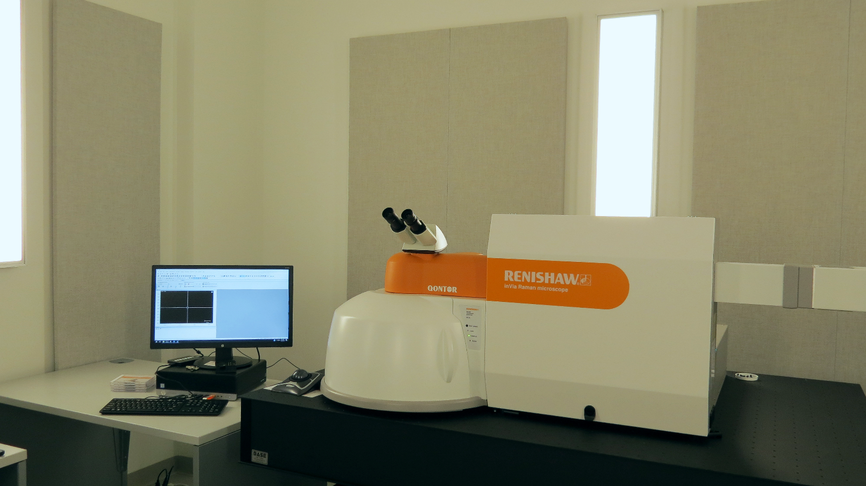

These instructions are intended for reference only, and will NOT replace the training required for proper system operation. Please contact MCF staff with questions or to report a system problem.

1. | Log into the tool in SUMS
2. | LASER POWER: Choose the laser you wish to use and turn on the laser with the key. It will take several minutes for the laser to stabilize. Check for the lights turn ON. | 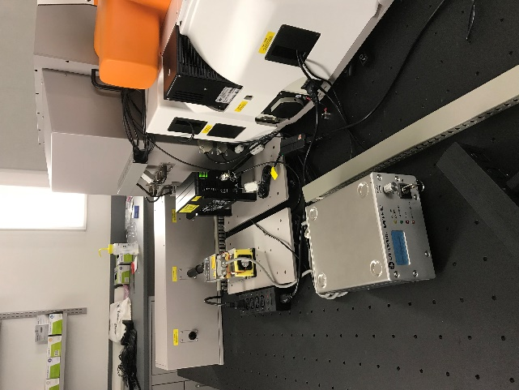
3. | PROGRAM: Open “Wire 5.1”  Program which should be on the left side of the desktop. | 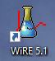
4. | Click “View sample under camera and objective.”  Use the sliders to adjust illumination. You may use the field (f) and aperture (A) controls to help focus. (if there is no surface feature you can focus on the edges of the field aperture)  Occasionally you may have to adjust the brightness/ contrast setting on the live video screen. (e.g. dark samples) | 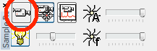  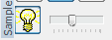
4. | Open the microscope door. Press “Door Release”. Lower the Z stage, so that there is enough clearance between the objectives and sample and that you accidentally do not touch the objectives.  If you have powder samples you may use the glass slide to load the samples (A tiny bit on the slide is enough).  For transparent samples (liquids or thin films) use an Aluminum foil to cover your glass slide. For liquid samples place a drop on the slide.  Make sure you select an objective (5, 20, 50, 100 X) and focus using X, Y, Z stage controls. Use the track ball for fine adjustments.  Note the Working distance is different for all 4 lenses. (Distance between the sample in focus and the lens). Select the matching objective on the WiRE screen to use the video screen. | 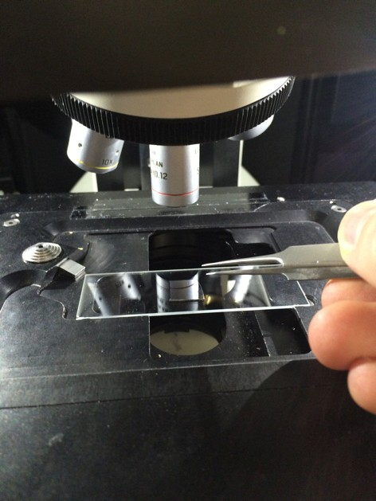

5. | Make the following settings in WiRe: View sample under video and laser. Laser shutter open. Lens set to the one you're using. Laser power 1%. Laser and grating set as needed for your sample | 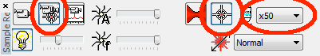
6. | Check that the laser is focused, and make fine adjustment with the trackball. If the spot is not centered in the crosshairs, do not adjust it! Contact staff. | 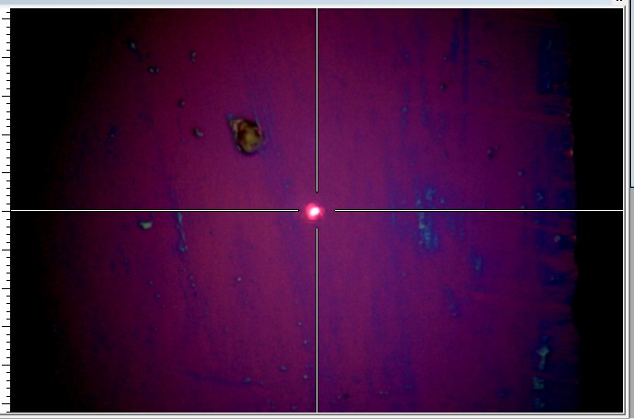

7. | New measurement →→ New spectral acquisition. Under Range: select Static, and laser and grating as needed. Bear in mind that these are just general guidelines for the setup of a basic measurement. Adjust as needed for your material. | 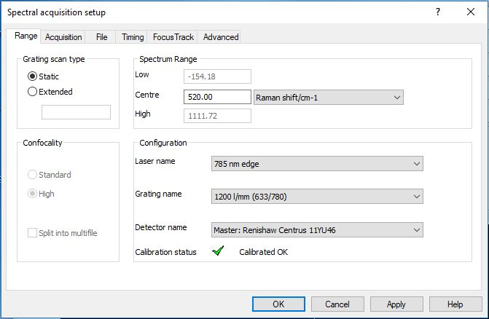
8. | Under Acquisition:  Exposure Time: 1 s  Laser Power: 0.5-5%  Accumulation: 1  Check "Close laser shutter on completion," "Restore instrument state on completion". For long scans it is advised to check “Cosmic Ray Removal.” Press Apply before moving to next screen. | 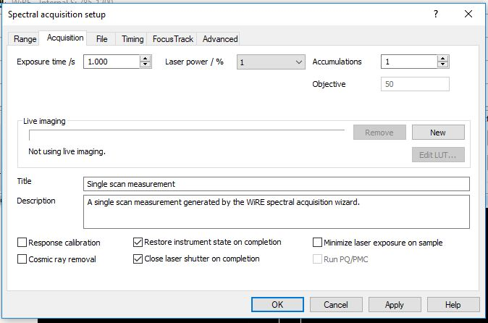
9. | Note: Files are not saved automatically. Choose a file name and directory where you would like to save the data.  If you wish to plot the data in excel, check “auto export to text.”  If running multiple spots on the same sample then check “Auto Increment” and the software will automatically append incrementing numbers to your data files. | 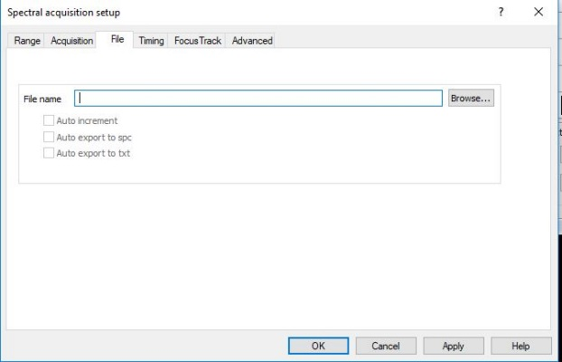

10 | Click Run to record a spectrum. Right-­‐click in the spectrum and choose Tools-­‐ Peak Pick. | 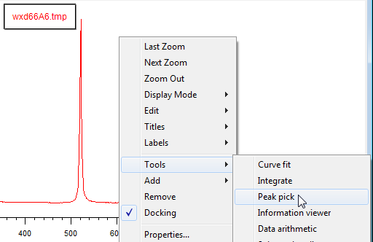
11 | . Check the laser shutter is closed. Open the microscope door and switch back to 5x lens. Load your sample and  repeat steps 4-­‐7, but choose your acquisition parameters as needed.  Guidelines: 488nm laser delivers ~30 mW at 100%. 785 nm laser : 300 mW at 100%. Note 785 laser is a line laser, use the pinhole for a smaller spot focus. ( power is reduced to 30 mW at 100 %)

12 | . Record your measurements. Don't forget to save each one using File-­‐-­‐Save. | 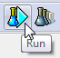
13 | .
14. | Check the schedule in SUMS and see if anyone is performing an experiment after you that day. If not, turn off the laser.
15. | Log out of the instrument in SUMS.

